ROJECT DESIGN PHASE – II
DocSpot – Online Doctor Appointment Booking System

1. Data Flow Diagrams (DFD)

1.1 DFD Level–0 (Context Diagram)
The DocSpot System interacts with four main external entities:
External Entities
- Patient
- Doctor
- Admin
- Notification / Email / SMS Service

Data Flow:
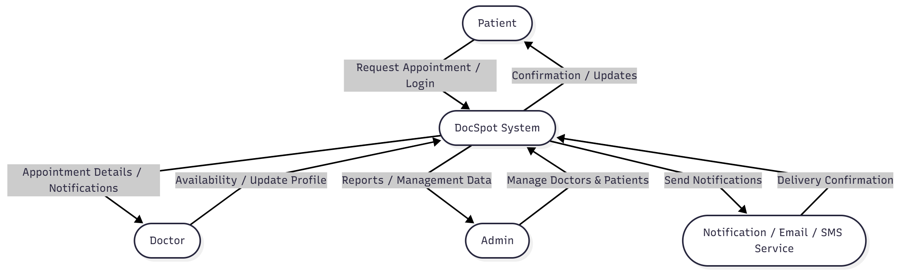

1.2 DFD Level–1

1. Patient Module
Inputs:
- Register
- Login
- Search doctors
- View doctor details
- Book appointment
- View medical history
- Receive notifications
Processes:
- Validate credentials
- Display doctor list
- Filter by specialization/location
- Generate appointment request
- Retrieve medical records
Outputs:
- Appointment confirmation
- Patient dashboard
- Medical history records

Data Flow :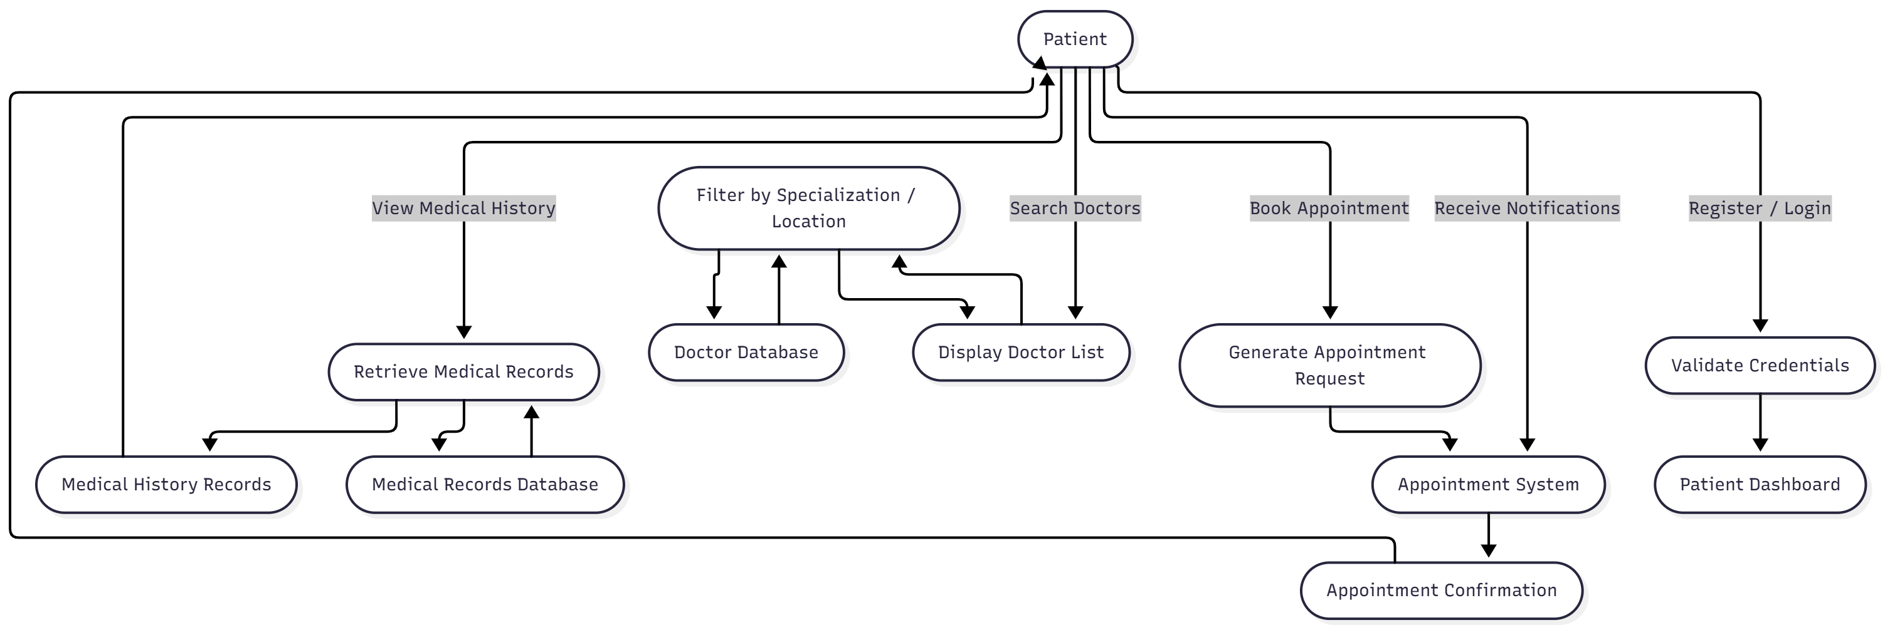

2. Doctor Module
Inputs:
- Doctor registration
- Update availability
- View appointment requests
- Approve/Reject/Reschedule appointments
- Upload prescription
Processes:
- Store doctor details
- Manage availability slots
- Validate appointment request
- Save prescription
Outputs:
- Updated availability
- Appointment status
- Prescription uploaded

Data Flow:
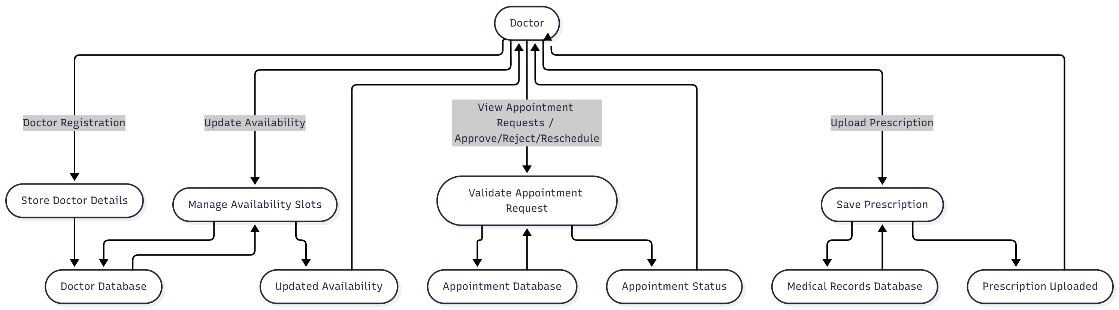

3. Appointment Module
Inputs:
- Patient appointment request
- Doctor approval/rejection
- Reschedule request
Processes:
- Check doctor availability
- Verify patient details
- Generate appointment ID
- Update appointment status
- Schedule notifications
Outputs:
- Appointment summary
- Status updates
- Doctor and patient notifications

Data Flow:

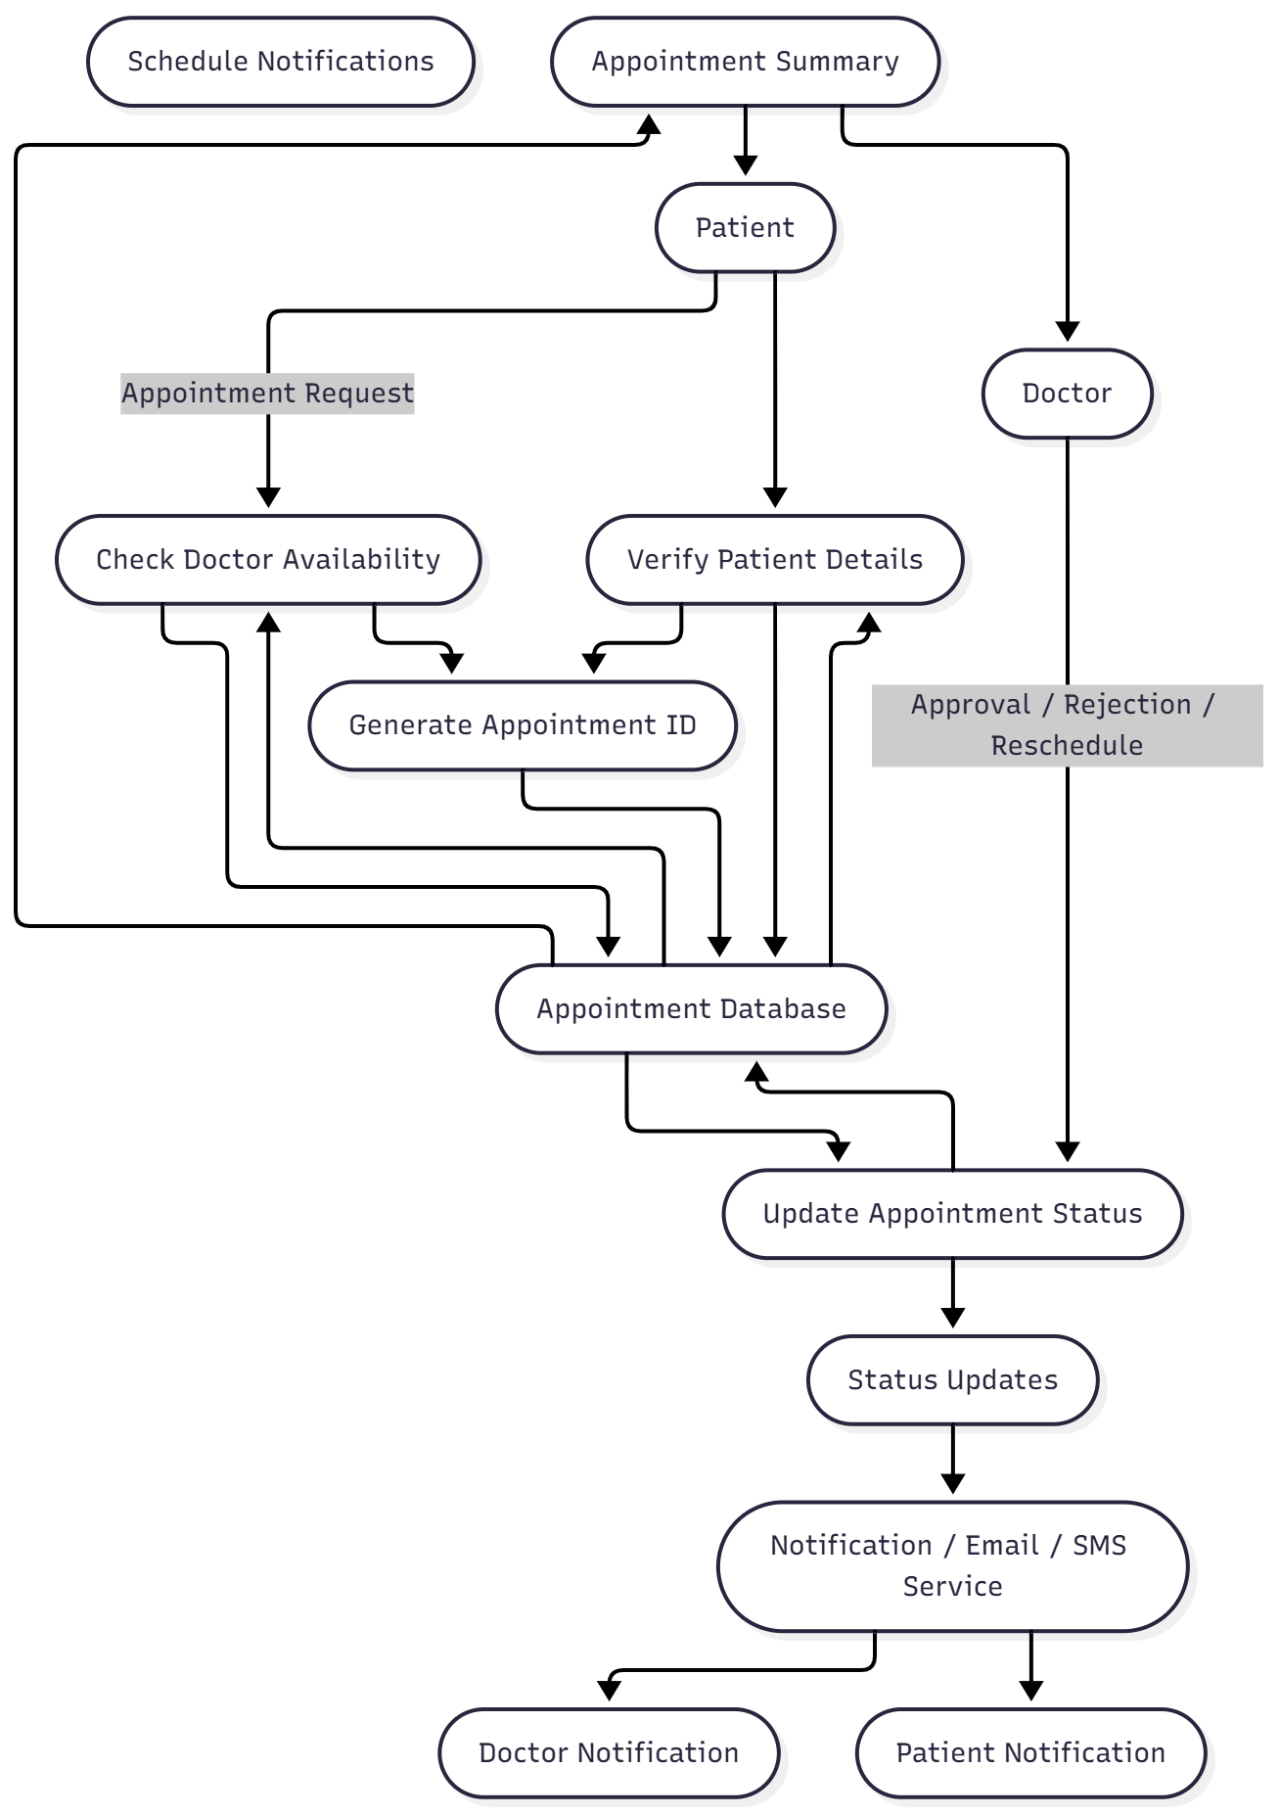

4. Medical Records Module
Inputs:
- Prescription upload
- Medical notes
- Past appointment data
Processes:
- Store records securely
- Retrieve records
- Map records to patient profile
Outputs:
- Patient medical history
- Prescription list
Data Flows:
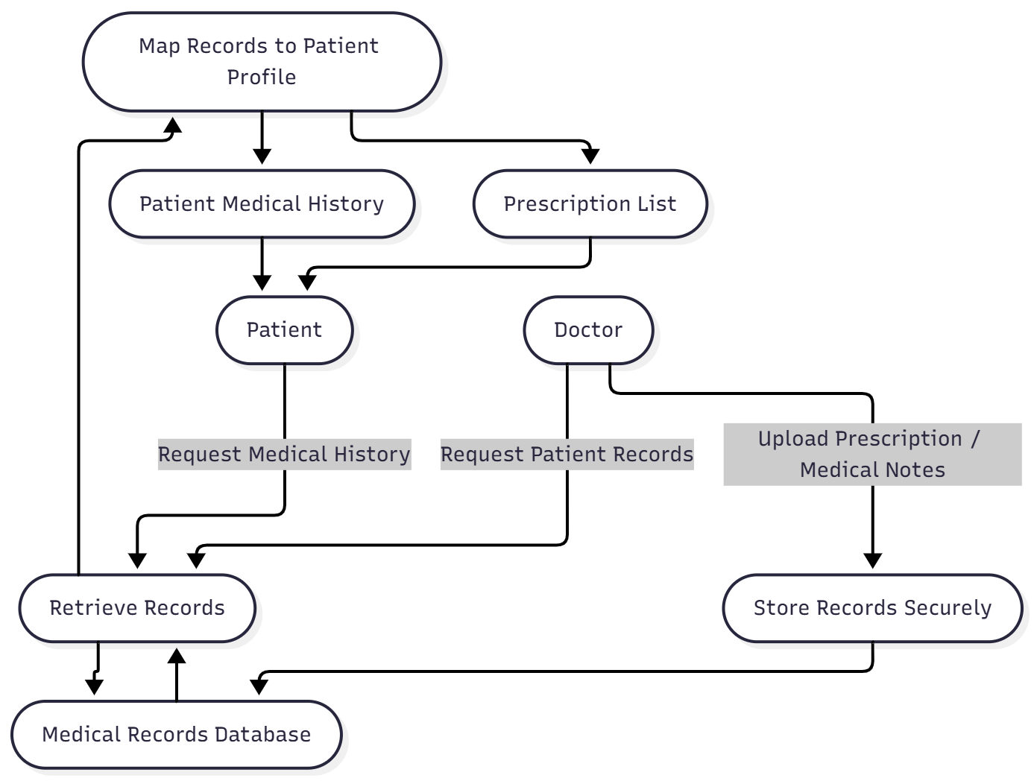
5. Admin Module
Inputs:
- Add/Edit/Delete doctors
- Verify doctor profile
- Monitor appointments
- Review system logs
Processes:
- Manage platform data
- Generate system reports
- Approve/reject doctor accounts
- Monitor user activity
Outputs:
- Updated doctor list
- Admin dashboard
- Platform reports
Data Flow:
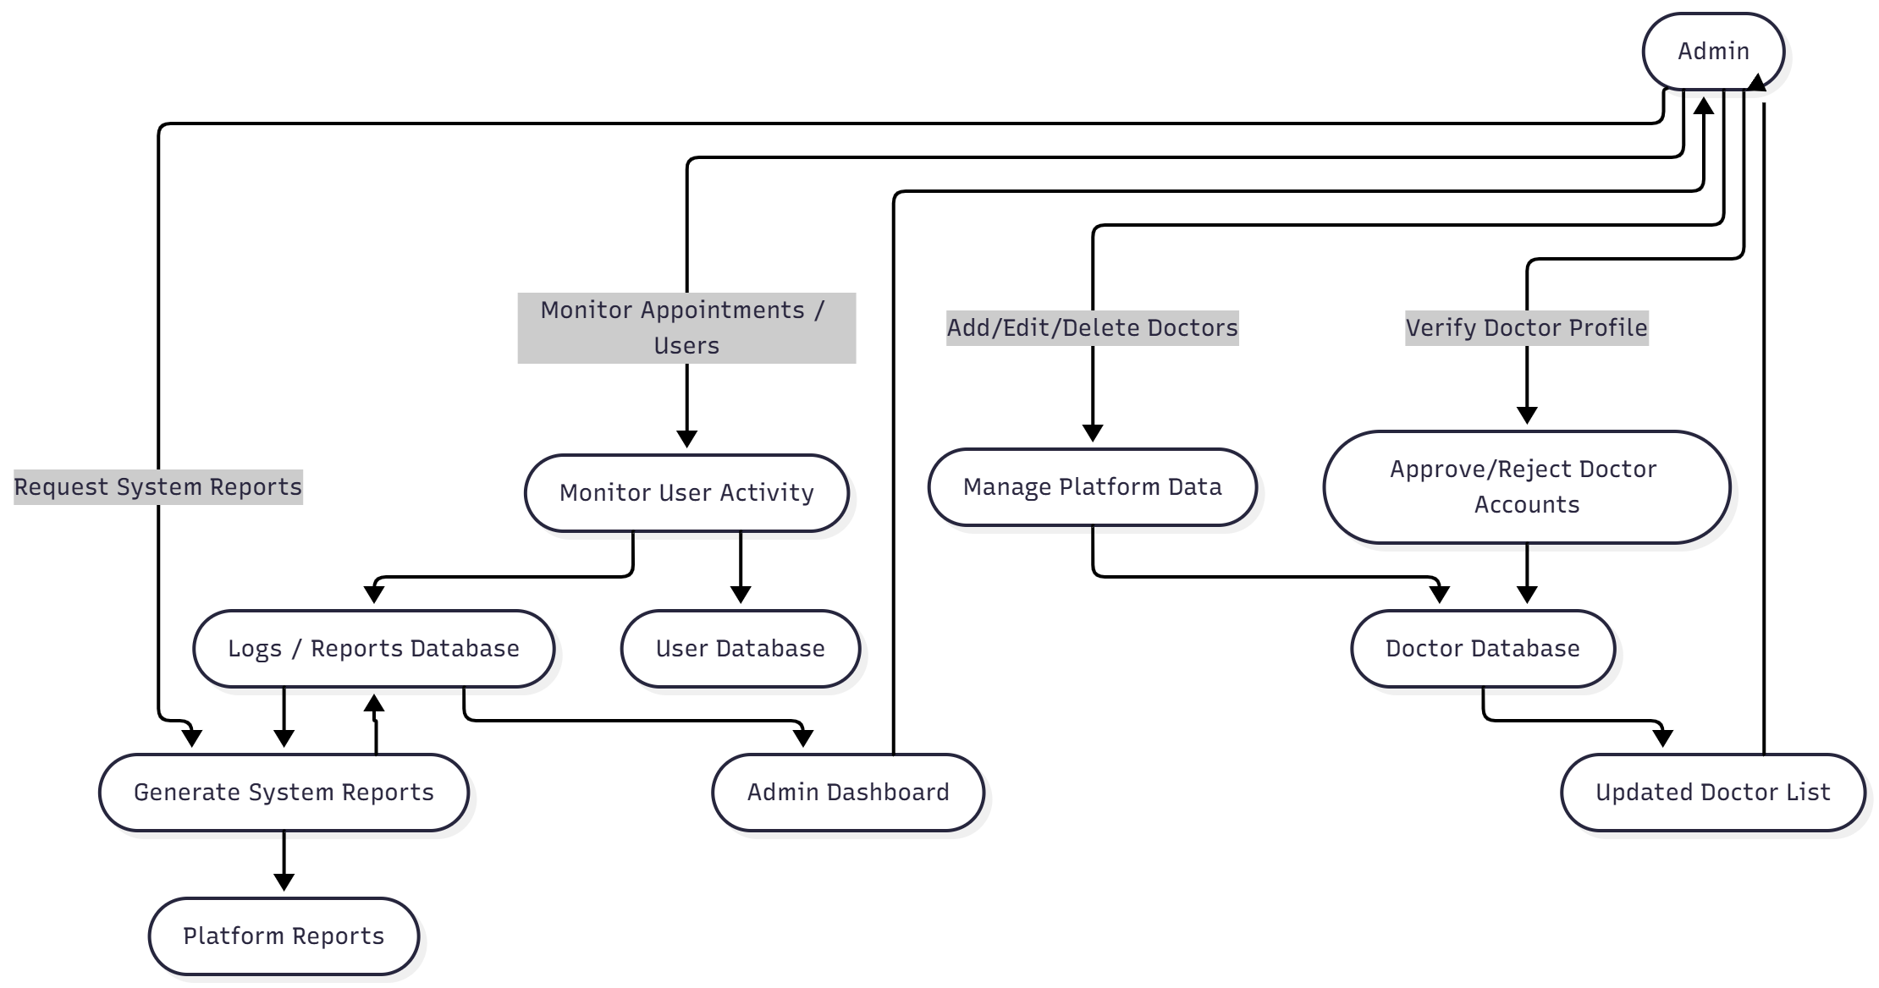

2. User Stories (Agile Format)

2.1 Patient User Stories
Authentication
- As a patient, I want to register so that I can book appointments.
- As a patient, I want to log in securely so that my medical data remains safe.
Doctor Search
- As a patient, I want to search doctors by specialization so that I can find the right doctor.
- As a patient, I want to view doctor details so that I can choose the best option.
- As a patient, I want to filter doctors by location/ratings so that I get relevant results.
Appointment Booking
- As a patient, I want to book appointments so that I get timely consultation.
- As a patient, I want to cancel or reschedule appointments if needed.
- As a patient, I want to receive confirmation messages so that I know my booking status.
Medical Records
- As a patient, I want to view my medical history so that I can track past consultations.
- As a patient, I want to download prescriptions so that I can use them for treatment.

2.2 Doctor User Stories
- As a doctor, I want to register and upload my qualifications so that patients can trust my profile.
- As a doctor, I want to set my available time slots so that patients can book correctly.
- As a doctor, I want to view all my scheduled appointments so that I can plan my day.
- As a doctor, I want to accept or reject appointments so that I control my schedule.
- As a doctor, I want to upload prescriptions so that patients receive proper medical guidance.
- As a doctor, I want to update my profile so that patients see accurate information.

2.3 Admin User Stories
- As an admin, I want to approve or reject doctor accounts so that only verified doctors are listed.
- As an admin, I want to monitor appointment activity so that I ensure system reliability.
- As an admin, I want to manage patient/doctor accounts so that the platform stays secure.
- As an admin, I want to generate system reports so that I can track platform performance.
- As an admin, I want to remove inactive or fake accounts so that the platform remains trustworthy.

